**CRUD Operations using Entity Framework Core**

We Use EF Core to perform CRUD operations that are following:

* Add data
* Update data
* Delete data
* Read data

1**)Adding data in table**

Here first we will create and initialize an object of our model class which is Student in our case.

Then we’ll create an instance of our Context class and push our created object in our database.

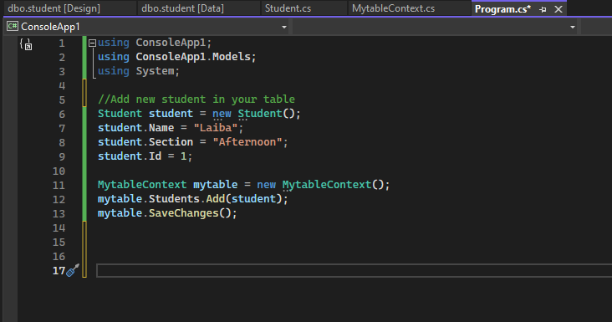

It will add data in your table as shown below;

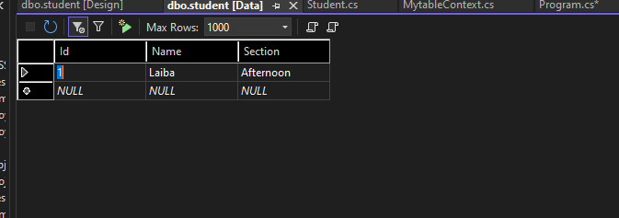

2**)Update data from table**

To update data, we’ll first fetch the desired records we want to update. In our case I’m fetching the first record from the table. Then update any of it’s attributes. Then commit changes by calling SaveChanges().

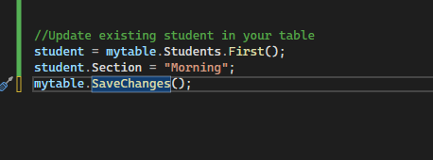

It will update data in your table as shown below;

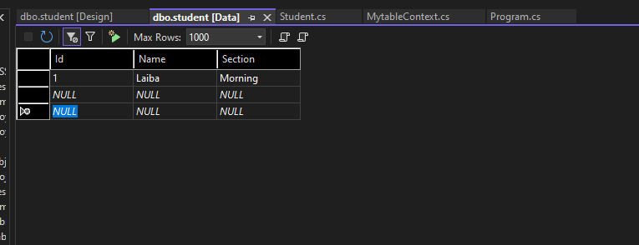

3**)Delete data from table**

Now to delete data we’ll fetch the object with the same procedure. Also we can give any additional condition for fetching as I’m fetching the record with Id “1”.

Then we will call Remove function and pass the object fetched to it.

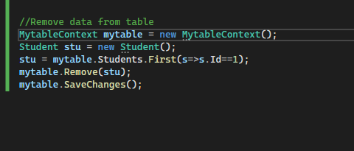

Here you can see that record with ID 1 is removed

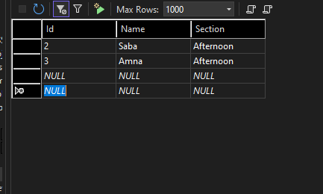

4**)Reading data from table:**

Here we will read all the records from table. We will use ToList() to make list of records read then use for each loop to print each one of them.

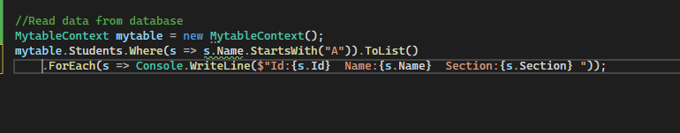

Here you can see that it is printing records having name starting with A.

